Name ___________________________________________ Date __________________ Block _____
Molecular Biology Online Lab
Go to http://www.phschool.com/science/biology_place/labbench/lab6/intro.html
There is also a link on the blog. Answer the bolded questions and fill in any missing blanks.
Introduction
In this laboratory you will use some basic tools of molecular biology to gain an understanding of some of the principles and techniques of genetic engineering. In the first part of the lab, you will use antibiotic-resistance plasmids to transform Escherichia coli. In the second part, you will use gel electrophoresis to separate fragments of DNA for further analysis.
- Define genetic transformation

In this part of the lab, you will introduce a gene for resistance to the antibiotic ampicillin into a bacterial strain that is killed by ampicillin. If the susceptible bacteria incorporate the foreign DNA, they will become ampicillin resistant.
2. Label this diagram and draw the plasmid.
- What does Ampicillin-sensitive mean?

- What does Ampicillin resistance mean?

Bacterial Colonies
The bacterium you use in your laboratory activity is ___________________________, which has been grown in a petri dish on Luria Broth (LB) agar. Each colony in the petri dish is made up of millions of individual cells.
- Summarize the information about E. coli (include where it is found, how it reproduces, any structural characteristics)
Plasmids
- Define plasmid

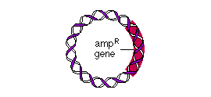
Some plasmids have the __________ gene, which confers ________________________________. E. coli cells containing this plasmid, termed _________________ cells, can survive and form colonies on LB agar that has been supplemented with _____________. In contrast, cells lacking the amp^{R} plasmid, termed _____________ cells, are sensitive to the antibiotic, which kills them. An ampicillin-sensitive cell (–amp^{R}) can be transformed to an ampicillin-resistant (+amp^{R}) cell by its uptake of a ___________________________________
To transform cells, you first need to make them ________________________________________
Competent Cells
- What must be altered to make E. coli competent?

- How are cells made competent?

- What type of cells are made competent most easily?

- Explain the reason for the lag phase.

- What is the name of the phase characterized by rapid growth?

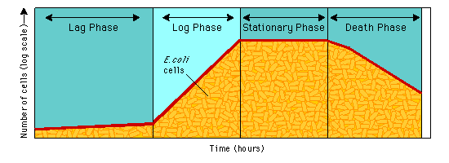
Design of the Experiment I
You now have an understanding of how cells are prepared for transformation. Before beginning the experiment, it's important to review the basics of sterile procedure.
Sterile Laboratory Procedure | The techniques of sterile procedure apply to any activity in which you work with bacteria or fungi. Since you are working with E. coli bacteria in this laboratory, it is important that you not contaminate your work with any foreign bacteria or expose yourself to potentially hazardous bacteria. The chart below summarizes the basics of sterile procedure.

ALWAYS | NEVER
Always wash your hands and work surface before beginning. | Never have food on your work surface.
Always keep the lid of the petri dish on it or over it at all times. Microbes are everywhere! | Never lay the lid of the petri dish or culture tube on the lab bench.
Always open all sterile tools carefully. | Never touch the end of a tool that touches bacteria.
Always keep hair pulled back and use goggles when flame is present. | Never throw biohazard materials in the regular trash.
Always wash your hands thoroughly with soap and hot water before leaving the lab.
Now you're ready to begin the experiment.
Transformation Procedure
In your laboratory, you use ___________________________________________________________________ gene to transform E. coli cells that lack this gene. The illustration below outlines the major steps in this procedure.
- What is the control group for this experiment?

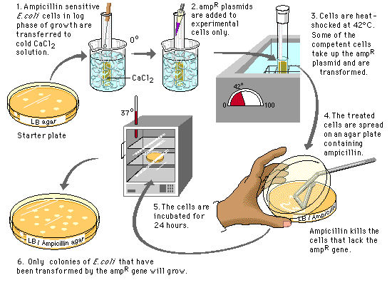
After you've familiarized yourself with the procedure as a whole, take a closer look at each stage. Select steps 1–4 and 6 to see what is going on at the cellular level.
- Why are the Ampicillin sensitive E. coli cells transferred to a cold CaCl₂ solution?

- Why are the cells heat shocked?

- What is LB agar?

- Why do we use a LB agar plate without Ampicillin?

Closer Look: Transformation Procedure:
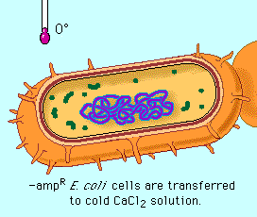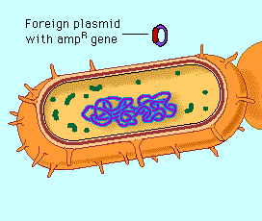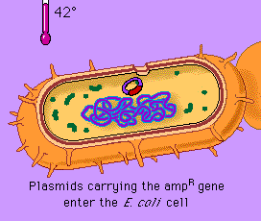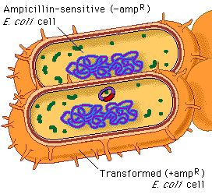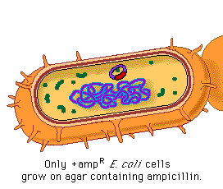
Analysis of Results I
- What will happen if there is not ampicillin on the plate?

- Which cells can grow on agar with ampicillin?

- Why will only some colonies grow on the ampicillin plates?
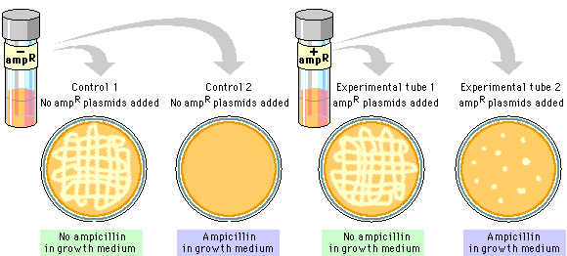
Now test your understanding of the results of your transformation experiment.

Label the Results of Your Experiment
After incubation, the following plates were removed from the incubator. All but part of one label have been removed so that you must now use your understanding of this laboratory to make new labels for each plate.
- 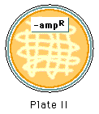
Lab Questions
In a molecular biology laboratory, a student obtained competent E. coli cells and used a common transformation procedure to induce the uptake of plasmid DNA with a gene for resistance to the antibiotic kanamycin. The results below were obtained.

24. On which petri dish do only transformed cells grow?
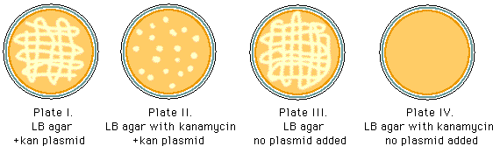
a. Plate I b. Plate II c. Plate III d. Plate IV
- Which of the plates is used as a control to show that non-transformed E. coli will not grow in the presence of kanamycin?
a. Plate I b. Plate II c. Plate III d. Plate IV
- If a student wants to verify that transformation has occurred, which of the following procedures should she use?
- Spread cells from Plate I onto a plate with LB agar; incubate.
- Spread cells from Plate II onto a plate with LB agar; incubate.
- Repeat the initial spread of –kan^{R} cells onto plate IV to eliminate possible experimental error.
- Spread cells from Plate II onto a plate with LB agar with kanamycin; incubate.
- Spread cells from Plate III onto a plate with LB agar and also onto a plate with LB agar with kanamycin; incubate.

- During the course of an E. coli transformation laboratory, a student forgot to mark the culture tube that received the kanamycin-resistant plasmids. The student proceeds with the laboratory because he thinks that he will be able to determine from his results which culture tube contained cells that may have undergone transformation. Which plate would be most likely to indicate transformed cells?
- A plate with a lawn of cells growing on LB agar with kanamycin
- A plate with a lawn of cells growing on LB agar without kanamycin
- A plate with 100 colonies growing on LB agar with kanamycin
- A plate with 100 colonies growing on LB agar without kanamycin

- A student has forgotten which antibiotic plasmid she used in her E. coli transformation. It could have been kanamycin, ampicillin, or tetracycline. She decides to make up a special set of plates to determine the type of antibiotic used. The plates below show the results of the test.
Which antibiotic plasmid has been used?
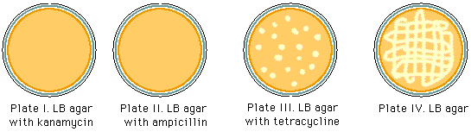
- Kanamycin b. Ampicillin c. Tetracycline

- A student has forgotten which antibiotic plasmid she used in her E. coli transformation. It could have been kanamycin, ampicillin, or tetracycline. She decides to make up a special set of plates to determine the type of antibiotic used. The plates below show the results of the test.
What is the explanation for these results?
- Plates I and II each contain a plasmid that is resistant to that antibiotic
- Plate II has antibiotic agar, but E. coli that has been transformed to be resistant to tetracycline can grow.
- Plate IV has no antibiotic
- There are no tetracycline-resistant cells on Plate II.
Key Concepts II: Electrophoresis
- What are restriction enzymes?

- What is a recognition sequence?

How Do Restriction Enzymes Work?
Like all enzymes, restriction enzymes are highly specific. They cut DNA only within very precise recognition sequences. Study the illustrations below to see three different recognition sequences. The red line shows where the enzymes will cut the DNA.
- What is a palindromic sequence? Why is it important for restriction enzyme analysis?

" This means that the recognition sequence on one DNA strand reads in the opposite direction on the complementary strand.
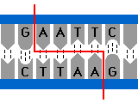 | 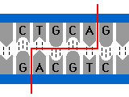 | 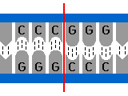
Next let's look at the laboratory procedures for cutting and separating DNA fragments.

Cutting DNA with Restriction Enzymes
You begin by mixing DNA with one or more restriction enzymes in a small plastic microcentrifuge tube. The total volume of the mix is about 20 µl.
Microscale Quantities
We use very small quantities when working with DNA, so the volumes and tools are adapted to this microscale. In the metric system, the prefix "micro-" indicates one-millionth. It is symbolized by µ, the Greek letter mu. Some examples are:
1 ml = 1000 µl (1000 microlitres)
1 mg = 1000 µg (1000 micrograms)

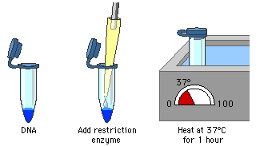

Most restriction enzyme reactions are incubated at 37°C for one hour. After incubation, you can analyze the DNA or use it in other kinds of reactions, such as the bacterial transformation you did in the first part of this lab.
In the next procedure, you will see how to analyze separate DNA fragments with gel electrophoresis.
Gel Electrophoresis
- How does gel electrophoresis separate molecules?

- What is DNA’s charge? Toward which electrode will the DNA migrate?

- Which fragments will migrate the farthest?

Design of the Experiment II
- What three samples of DNA from bacteriophage lambda are used?

- What are the 3 steps in this lab?

The figure below is an overview of the procedure, using generalized DNA samples. Over the following several pages we look at the procedure step by step.
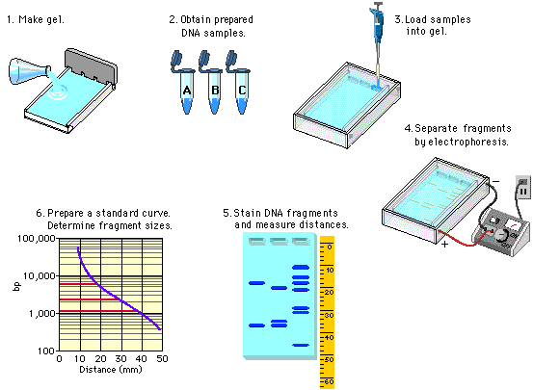

Preparing the Gel
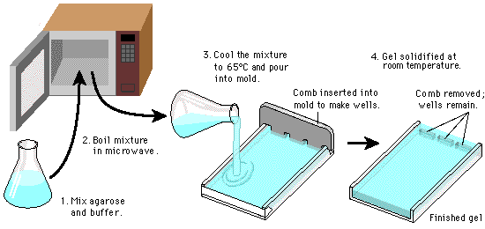
After making the gel, place it in an electrophoresis chamber and add buffer to cover the gel.
Be sure the wells are placed at the negative electrode end.
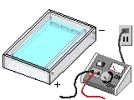
The apparatus is now ready to load. Do not turn on the electricity yet!

Loading the Gel
- What is the purpose of the tracking dye?
- Does the dye stain DNA? How does the dye work?

- What is the purpose of the sucrose or glycerol?

Use a micropipette to load 5–10 µl from each reaction tube into a well. (Your instructor may vary this procedure and have you load the wells with DNA before you pour the buffer.)
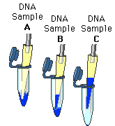
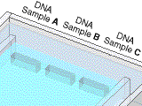
Filling the Wells
Hint: Hold the micropipette just over the well. Be careful not to puncture the bottom of the well with the micropipette!
Electrophoresis
Place the top on the electrophoresis chamber and connect the electrical leads to the gel. Double check that the wells are at the negative electrode.
When you turn on the power, the DNA/tracking dye combination will begin to move toward the positive electrode.
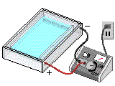
Running the Gel
Although you cannot see the DNA, you can monitor the movement of the tracking dye. You turn off the power when the tracking dye has moved near the end of the gel.
Staining and Photographing the DNA
- What is the purpose of staining the gel?

After staining the gel, photograph it for analysis.
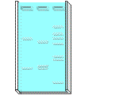
If a camera is not available, wrap the gel in plastic wrap and use a marking pen to outline the wells and locate the bands.
Analysis of Results II
- What is the purpose of the maker DNA?
In your laboratory, the DNA that has been cut with HindIII is the marker; you will use it to help you determine the fragment sizes in the EcoRI digest. On the next pages we go through the procedure using HindIII and two generalized DNA samples.

Making a Standard Curve for HindIII DNA Fragments
If you know the fragment sizes in the HindIII digest, how do you determine the fragment sizes in an unknown sample? You use data from the marker to prepare a standard curve, which will provide a standard for comparison to the unknown fragment sizes. Using a standard to estimate an unknown is sometimes called "interpolation"; you will interpolate the size of the unknown fragments.
You begin by making a standard curve for the known sample, DNA plus HindIII. Measure the distance each HindIII fragment migrated on the gel and then complete the chart. It is very difficult to get exact numbers as you read this graph. If your response is in a close range, that is acceptable.
- Fill in the table
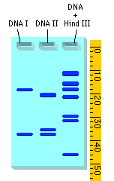 | Actual Base Pairs Measured Distance (mm)  23,130  9416  6557  4361  2322  2207  564
Making a Standard Curve
When the data obtained for the marker DNA is plotted on semilog graph paper, it is an almost straight line. This is the standard curve.
Hint: Be very careful when working with log-based numbers. Small mistakes in reading from the y-axis translate into big mistakes in determining base-pair lengths.
In your lab, you will use the standard curve to determine the fragment sizes of the EcoRI digest. On the next two pages, you practice the procedure using two samples with unknown fragment sizes, DNA I and DNA II.

- Practice Problem #1
 | Distance Migrated (mm) | Interpolated Fragment Size (in base pairs)
Fragment 1
Fragment 2
Fragment 3
- Practice Problem #2
 | Distance Migrated (mm) | Interpolated Fragment Size (in base pairs)
Fragment 1
Fragment 2
Lab Questions – Part 2
- Which of the following statements is correct?
- Longer DNA fragments migrate farther than shorter fragments.
- Migration distance is inversely proportional to the fragment size.
- Positively charged DNA migrates more rapidly than negatively charged DNA.
- Uncut DNA migrates farther than DNA cut with restriction enzymes.

- How many base pairs is the fragment circled in red on the website?
- 0.08 ml/min
- 0.04 ml/min
- 0.8 ml/min
- 0.1 ml/min
- 1.00 ml/min

- An instructor had her students perform this laboratory beginning with setting up their own restriction enzyme digests. One team of students had results that looked like those below.
What is the most likely explanation for these results?
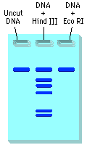
- The students did not allow enough time for the electrophoresis separation.
- The agarose preparation was faulty.
- The methylene blue did not stain the DNA evenly.
- The restriction enzyme EcoRI did not function properly.
- The voltage was set too low on the apparatus.
Below is a plasmid with restriction sites for BamHI and EcoRI. Several restriction digests were done using these two enzymes either alone or in combination. Use the figure to answer questions 4–6.
Hint: Begin by determining the number and size of the fragments produced with each enzyme. "kb" stands for kilobases, or thousands of base pairs.
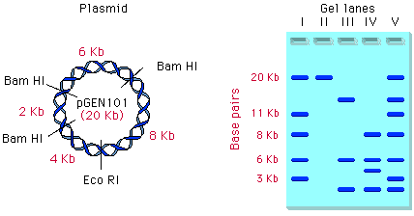
- Which lane shows a digest with BamHI only?
- I b. II c. III d. IV e. V
- Which lane shows a digest with EcoRI only?
- I b. II c. III d. IV e. V

- Which lane shows the fragments produced when the plasmid was incubated with both EcoRI and BamH1?
a. I b. II c. III d. IV e. V

53. A restriction enzyme acts on the following DNA segment by cutting both strands between adjacent thymine and cytosine nucleotides
............TCGCGA........... ..........AGCGCT...........
Which of the following pairs of sequences indicates the sticky ends that are formed?
a. …GCGC CGCG…
b. …TCGC TCGC…
c. …T T…
d. …GA GA…
e. …GCGC GCGC…

- A segment of DNA has two restriction sites–I and II. When incubated with restriction enzymes I and II, three fragments will be formed–a, b, and c. Which of the following gels produced by electrophoresis would represent the separation and identity of these fragments?
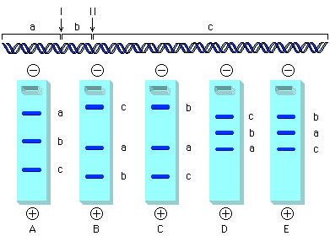

- Extension: Research the practical applications for bacterial transformation and gel electrophoresis. Include the field of use, major discoveries or treatments made using the technology, and other interesting facts. Provide your sources. Include your information on this page.

SEE NEXT PAGE
- What is gene therapy? Research gene therapy and its applications. What diseases make good candidates for gene therapy? What are some problems with gene therapy today? Cite your sources. Do NOT copy directly from a single cite. Wikipedia is not an appropriate source.

