Name ________________________________ Box # _____

Human Reproduction Review

- Which 3 hormones influence testosterone production?
  - FSH & estrogen
  - FSH, LH, GnRH
  - FSH & LH
  - Progesterone, LH, FSH

- Name the 3 phases of the menstrural cycle in order:
_________________________________

_________________________________

_________________________________

- Use the following diagram to answer the questions a-b:

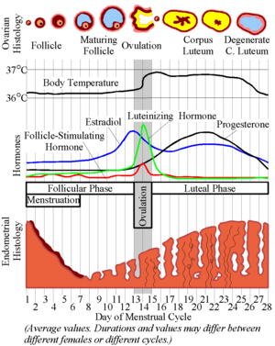

a. Name the two hormones that cause the follicle to grow. ______________________

b. Which hormone is released during ovulation and causes the follicle to burst? _______________________

c. Which hormone maintains the uterine lining? _______________________________

4. Which hormone causes the corpus luteum to continue releasing progesterone, if there is a baby present? _____________________________.

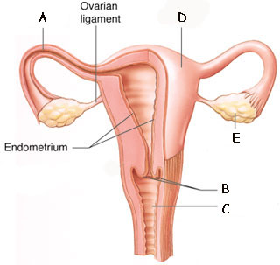

5. Identify the labeled diagram to the left:

A ____________________________________

B ____________________________________

C ____________________________________

D ____________________________________

E ____________________________________

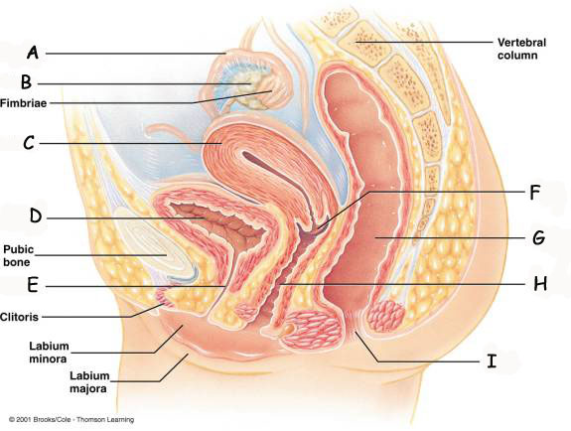

6. Identify the labeled diagram to the left:

A ____________________________________

B ____________________________________

C ____________________________________

D ____________________________________

E ____________________________________

F ____________________________________

G ____________________________________

H ____________________________________

I ____________________________________

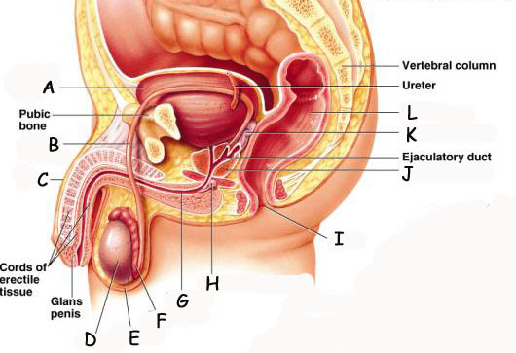

7. Identify the labeled diagram above:

A ____________________________________

B ____________________________________

C ____________________________________

D ____________________________________

E ____________________________________

F ____________________________________

G ____________________________________

H ____________________________________

I ____________________________________

J ____________________________________

K ____________________________________

L ____________________________________

8. Gastrulation is the development of the 3 germ layers (gastrula). Identify the week during fetal development in which this stage occurs. Also, identify the three layers that are formed during this process.

Fill in the blank:

9. By end of week ____________ all body systems & organs are formed.

10. Sensory organs develop, and the fetus responds to noise during the _________ week.

11. Name 3 techniques used to diagnosis the Fetus:

___________________________________________________

___________________________________________________

___________________________________________________

- The beginning of the birthing process is called ________________________________.

- Name the three stages of birth in order:

__________________________________________________________________________________

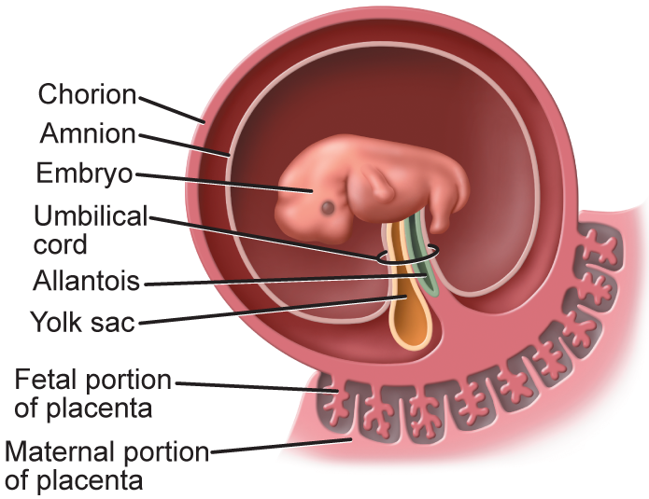
B
C
D
A

14. Label the four extraembryonic membranes:

A ____________________________

B ____________________________

C ____________________________

D
____________________________

- Define “teratogens.” Give three examples and their effects on fetal development. One answer must include the effects of fetal alcohol syndrome.

Teratogen =

A. Fetal Alcohol Syndrome =

B.

C.

