Name: ___________________________________

Cellular Respiration: Virtual Lab
The Biology Place - Lab Bench Activity - Cellular Respiration
www.phschool.com ------> go to "The Biology Place" -----> go to LabBench ---> go to "Lab 5: Cell Respiration"
1. In this lab activity:
a) You will observe __________________________________________________________________
b) You will investigate ________________________________________________________________
2. Write the equation for cellular respiration:

3. What are the three ways in which you can measure the rate of cellular respiration?

4. Sketch a respirometer and label its important features.

5. As the organism inside the respirometer consumes oxygen, what happens to the water?
6. What happens to the CO2 that the organism produces?

7. Experimental Setup (View the graphic)
a) fill out the table
 | Vial 1 | Vial 2 | Vial 3 | Vial 4 | Vial 5 | Vial 6
Contents
Temperature
b) How do you ensure that each vial has an equal volume?
c. What is the purpose of the vial with only glass beads?

8. Analyzing results.
a) What is the equation to determine the rate of respiration?
b) What is X? What is Y?
9. Read the respirometers and determine the rate of respiration. Show your work.
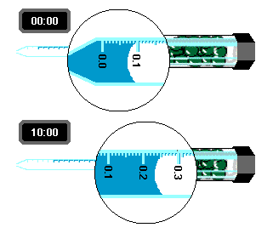
10. Analysis - Self Quiz
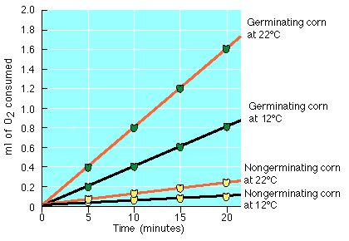
- Describe the relationship between temperature and the consumption of oxygen.

- Calculate the rate of consumption of germinating corn at 12 degrees C.

- Based on the graph would you conclude that non germinating seeds respire?

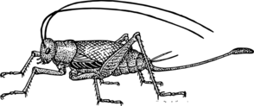
11. Extension (you can do this at home. Computer not required)
A cricket is placed in a respirometer and data was taken at three temperatures. The following table shows the data collected.
 | Temperatures
Time (min) | 10 degrees | 18 degrees | 25 degrees
0 | 0.0 | 0.0 | 0.0
5 | 0.25 | 0.6 | 0.9
10 | 0.5 | 0.9 | 1.4
15 | 0.7 | 1.2 | 1.8
20 | 0.9 | 1.6 | 2.4
- Graph the data

B) Determine the rate of respiration for each of the three temperatures. (Show work)

C) Write a paragraph stating your conclusions related to temperature’s effect on respiration rate. Include an explanation of why the observed effects take place.

- A similar experiment can be carried out using yeast cells. The yeast cells are placed in a sugar solution that provides the glucose for cellular respiration. Design an experiment that measures the effect of the pH of the sugar solution on the rate of cellular respiration. Include a prediction of the results on a sheet of graph paper.

