AP Biology: Cellular Respiration Diagram

- On the “cell” provided label the following:
Mitochondrial Membrane- color orange
Mitochondrial Matrix- color yellow

- Label the following processes in the correct locations:
Glycolysis
Conversion of pyruvate to acetyl CoA
Kreb’s Cycle
Electron Transport Chain

- For each of the processes above include the following:
Reactants and Products
Amount of ATP, NADH, FADH₂ produced
An explanation in words of what occurs in each

- Draw a star next to the name of the process(es) that use oxidative phosphorylation to form ATP
- Draw a smiley face next to the name of the process(es) that use substrate level phosphorylation to form ATP
- Explain which processes occur if oxygen is NOT present
- Explain the importance of chemiosmosis for the production of ATP
- Explain the phrase proton motive force as it relates to the production of ATP
- Explain the function of NADH and FADH₂

Cell Membrane

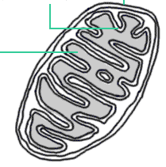
Cytoplasm

